[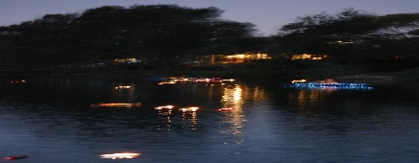](http://www.google.com.au/imgres?q=floating+candles+in+water&hl=en&biw=1366&bih=641&tbm=isch&tbnid=8lvRb4pfUl36NM:&imgrefurl=http://www.tumblr.com/tagged/floating%20candles&docid=hXL4aigSC4lfgM&imgurl=http://25.media.tumblr.com/tumblr_lmc88y8xvD1qbbcr0o1_500.jpg&w=500&h=332&ei=HVZCUfOcA4zMkgXO04GIDA&zoom=1&sa=X&ved=0CIwCEIQcMD0&ved=1t:3588,r:61,s:0,i:268&iact=rc&dur=3529&page=3&tbnh=172&tbnw=239&start=42&ndsp=24&tx=102&ty=104) 

Earth Hour – Floating Candles on River

***The Cooks River Valley Association*** (CRVA) is again holding

a Floating Candles Event to celebrate Earth Hour on

***Saturday 29 March from 6.30pm to 8.30pm*** at

Steel Park, Marrickville.

Make your own floating paper boat & bring it along to the event.

We can wax waterproof it for you

***We will provide candles***

The **River Canoe Club** will be sending along canoes & kayaks with fairy lights

[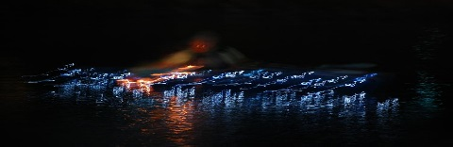](http://www.google.com.au/imgres?q=lighted+canoes&um=1&hl=en&sa=N&qscrl=1&rlz=1T4ACAW_enAU416AU416&biw=1366&bih=641&tbm=isch&tbnid=RJ2pXeP1CxAEJM:&imgrefurl=http://firsthandpictures.com/blog/petalumas-holiday-lighted-boat-parade/&docid=CgWIhNPo2WeJDM&imgurl=http://firsthandpictures.com/blog/wp-content/uploads/111203-004-sRGB_1024res_wm.jpg&w=1072&h=731&ei=PmNCUYrsPJGUiAfe64GYBw&zoom=1&ved=0CLQCEIQcMEk&ved=1t:3588,r:73,s:0,i:308&iact=rc&dur=5479&page=4&tbnh=178&tbnw=263&start=67&ndsp=23&tx=124&ty=88)

***Musical entertainment*** by local jazz group ***The Hungry Trio*** [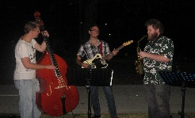](http://www.google.com.au/imgres?imgurl=http://www.ekcsk12.org/faculty/jventura/musicnotes4wq6.jpg&imgrefurl=http://www.ekcsk12.org/faculty/jventura/&h=771&w=1011&sz=111&tbnid=BB88WxrftFWXzM:&tbnh=90&tbnw=118&prev=/search?q=musical+symbols&tbm=isch&tbo=u&zoom=1&q=musical+symbols&usg=__SRe9i2pL_bu8EwwfN8su46OIJK4=&docid=qX2xB4l2qMU4yM&hl=en&sa=X&ei=hV1CUeuCMISPkwWL6ICYAw&sqi=2&ved=0CEUQ9QEwBQ&dur=3209)

Bring along your [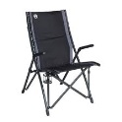](http://www.google.com.au/imgres?q=chair&start=263&um=1&hl=en&sa=N&qscrl=1&rlz=1T4ACAW_enAU416AU416&biw=1366&bih=641&tbm=isch&tbnid=4z8WDu3mWtZDAM:&imgrefurl=http://www.colemanaustralia.com.au/gear/furniture/flat-fold-chairs/padded-bungy-chair.aspx&docid=RNRXKTnO1-383M&imgurl=http://www.colemanaustralia.com.au/uploadedImages/Deluxe%20Bungy%20Chair.jpg&w=500&h=500&ei=Wl5CUY76N8mnkQXJ7oCwCg&zoom=1&ved=0CNABEIQcMEQ4yAE&ved=1t:3588,r:68,s:200,i:208&iact=rc&dur=1090&page=10&tbnh=185&tbnw=203&ndsp=28&tx=84&ty=83) [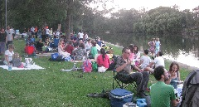](http://www.google.com.au/imgres?q=picnic+blanket&hl=en&sa=X&qscrl=1&rlz=1T4ACAW_enAU416AU416&biw=1366&bih=641&tbm=isch&tbnid=q2Jyz4GTPUNkfM:&imgrefurl=http://www.vat19.com/dvds/tuffo-outdoor-waterproof-blanket.cfm&docid=sNHaw_P_rxY3-M&imgurl=http://images1.vat19.com/waterproof-outdoor-blanket/waterproof-picnic-blanket.jpg&w=475&h=316&ei=rl5CUbPbHc2alQWzj4DACw&zoom=1&ved=0CPIBEIQcMCo&ved=1t:3588,r:42,s:0,i:242&iact=rc&dur=3435&page=3&tbnh=179&tbnw=202&start=37&ndsp=24&tx=107&ty=92) [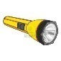](http://www.google.com.au/imgres?q=flashlight&um=1&hl=en&sa=N&rlz=1T4ACAW_enAU416AU416&biw=1366&bih=641&tbm=isch&tbnid=uJieTTcpbTN9zM:&imgrefurl=http://www.123rf.com/photo_8333719_fully-editable-illustration-of-isolated-flashlight.html&docid=uGdGpyXg-QwjLM&imgurl=http://us.123rf.com/400wm/400/400/pilgrimartworks/pilgrimartworks1011/pilgrimartworks101100007/8333719-fully-editable-illustration-of-isolated-flashlight.jpg&w=1200&h=1200&ei=IV9CUcaXPI6nkAX2poHoDw&zoom=1&ved=0CIoCEIQcMCU&ved=1t:3588,r:37,s:0,i:266&iact=rc&dur=876&page=2&tbnh=176&tbnw=174&start=18&ndsp=24&tx=101&ty=80) [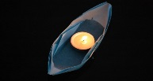](http://www.google.com.au/imgres?q=paper+boat&start=261&um=1&hl=en&sa=N&qscrl=1&rlz=1T4ACAW_enAU416AU416&biw=1366&bih=641&tbm=isch&tbnid=Rvr2BEHngvty4M:&imgrefurl=http://bjamminbillyblue.blogspot.com/2011/05/cause-symbol-paper-boats.html&docid=q6GiygSb2lHWoM&imgurl=http://3.bp.blogspot.com/-HdHR1Jcarl4/TcZkRNCchII/AAAAAAAAACU/asN0b7u-Jos/s1600/paper-boat.jpg&w=1600&h=628&ei=H2BCUYvHCIfDkAWI6oDIBQ&zoom=1&ved=0CPEBEIQcME84yAE&ved=1t:3588,r:79,s:200,i:241&iact=rc&dur=5068&page=13&tbnh=136&tbnw=348&ndsp=24&tx=169&ty=79) have a picnic by

the River, celebrate Earth Hour, enjoy the music and catch up with other River folk.

***(Gold coin donation)***

For further information contact Peter (0405 549 356) or [info@crva.org.au](mailto:info@crva.org.au)

 

www.rivercanoeclub.com www.crva.org.au