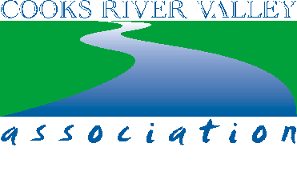
Citation for Life Membership Gayle ADAMS 27th October 2015
Gayle Adams has made many outstanding contributions to the work of the Cooks River Valley Association and the community of Cooks River people.
Among her many achievements Gayle initiated and set up the water monitoring program for the Association, resulting in a valuable body of data relating to the health of the Cooks River. Gayle then successfully used this information to raise the profile of the River with key government agencies, including Sydney Water, the NSW Health Department, Beach Watch and local governments. Gayle’s efforts also won the CRVA the Best Streamwatch Group Award for 2012.
Gayle’s submission to the NSW Health Minister in 2009 about potential health issues related to poor water quality in the Cooks River, led to ongoing stakeholders meetings convened by the Sydney Local Health District Public Health Unit.
With Doctor Stuart Kahn from UNSW, Gayle conducted research into the origin of E.coli pollution in local stormwater drains in Dulwich Hill, which proved conclusively that sewage was entering the stormwater system. This forced remedial action from appropriate authorities.
Gayle also set up the CooksEye Pollution Reporting Program for the Association which streamlined and monitored reports of pollution incidents on the River and ensured that appropriate authorities responded to these incidents.
Gayle was instrumental in organising and publicising the Cooks River Non-swimming Carnival in 2013. She also collected stories from locals who had swum in the river in former times. She initiated the postcard campaign, resulting in hundreds of postcards featuring an image of the Steel Park Lifesavers, 1932, being addressed to the Premier of NSW to launch the CRVA’s Cooks River - Swimmable by 2020 campaign.
In all of her contributions Gayle demonstrated an outstanding level of expertise and rigour. Her capacity to engage and influence the members of various government organisations has been invaluable in achieving the goals of the CRVA.
Gayle Adams’ contributions have had a significant and long-term impact on the status and recognition of the work of the Cooks River Valley Association.
It is in recognition of these contributions and of her services to the Association and to the Cooks River Valley community that the CRVA proudly confers life membership to Gayle Adams.

John Butcher President

