Wave Rock Report 2013/14
Wave Rock is a sandstone outcrop running beside Cooks River in Marrickville Golf Course. The site is about 70 metres long and 4 metres wide. The site has been identified in The Missing Jigsaw Pieces. The Bushland Plants of the Cooks (Benson et al 1999) as a potential focus for re-vegetation with appropriate woodland and heath species
The site is now 14 months young and we have planted more than 1200 native grasses, bushes and shrubs. A monthly, mid-week working bee has been well supported by Mudcrabs volunteers, Damon Bassett from Marrickville Council and staff from Marrickville Golf Course. Pleasingly we have also had a number of corporate volunteers come to work the site with us. This has provided much appreciated assistance. The vegetation is just beginning to take off with some recent rain. Many plants are flowering and setting seeds.
The Wave Rock site is situated just below a newly installed rain garden in the adjacent fairway of the golf course and will fit in well with the bush regeneration work along the sandstone escarpment in Beauchamp St.
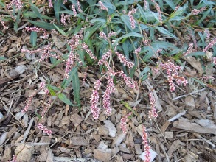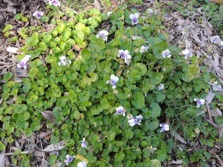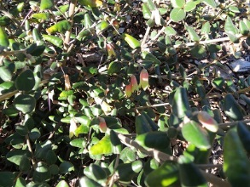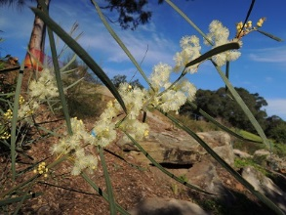

Some of the winter blossoms at Wave Rock

