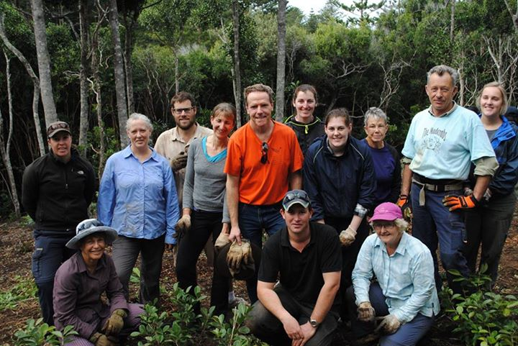

The Travel Centre Norfolk Island

Norfolk Island has a totally unique environment and is recognised as a global biodiversity hotspot. This week we've had 13 visitors who have been able to personally appreciate that fact by working on conservation and restoration work around the island. Our partnership with Wildmob, a not-for-profit organisation dedicated to conserving Australia's most threatened species and ecosystems, means regular groups will be travelling here throughout the year to go on an adventure and help save our endangered species and restore our habitats. Sounds like you? Check out the next trip happening in November...

